SSMS SQL EXERCISE
Q1. View the first 100 rows of the dataset to understand its structure.

ANS:

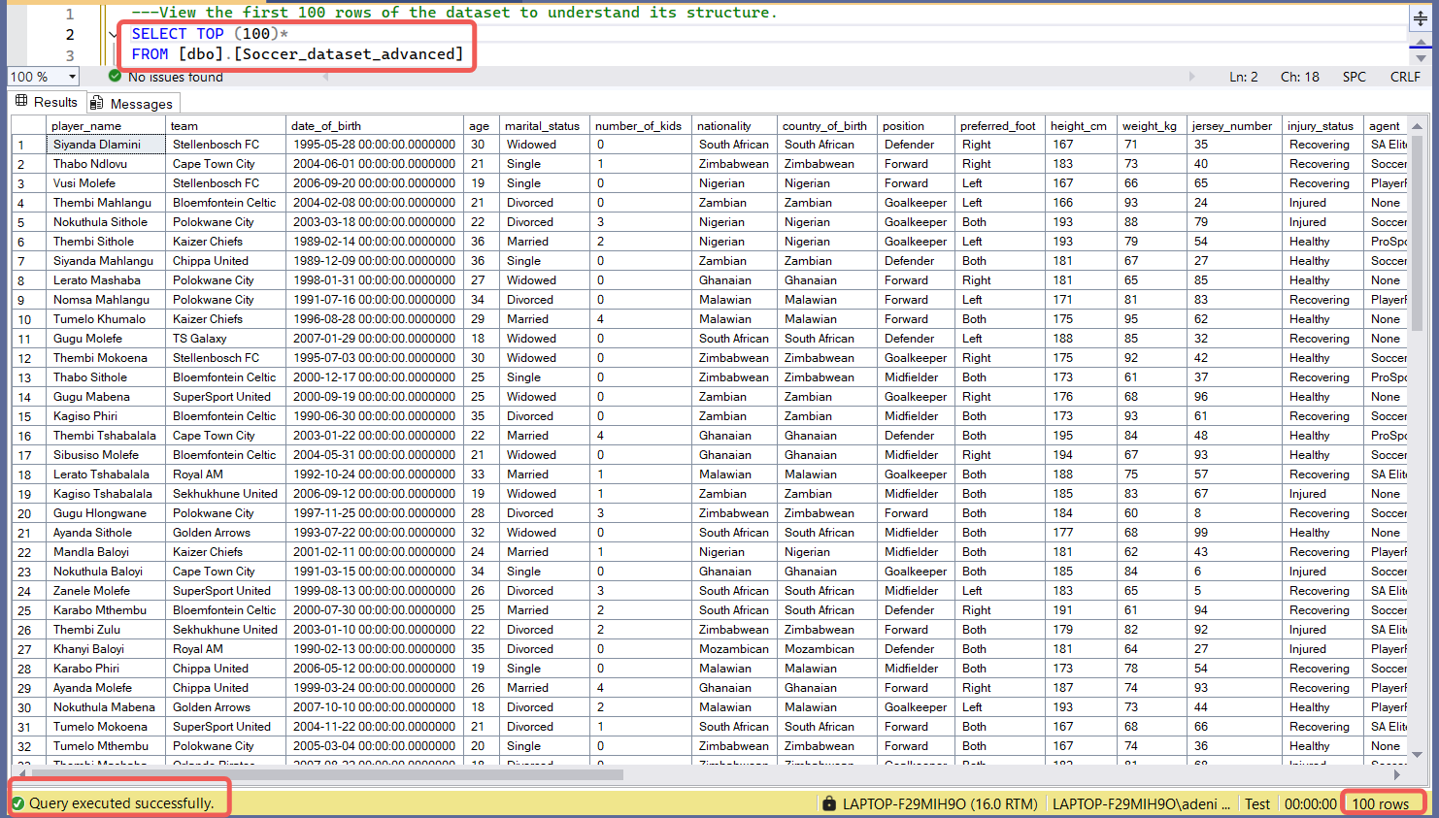

Q2. Count the total number of players in the dataset.

ANS:

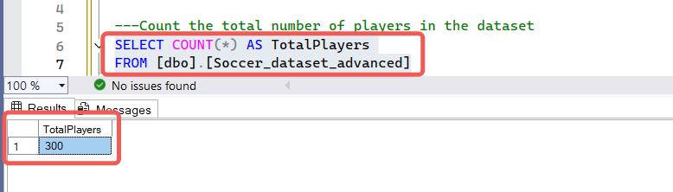

Q3. List all unique teams in the league.

ANS:

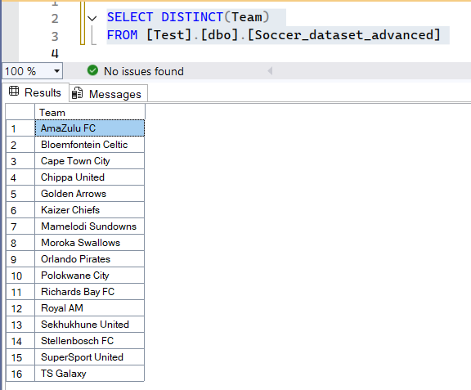

Q4. Count how many players are in each team.

ANS:

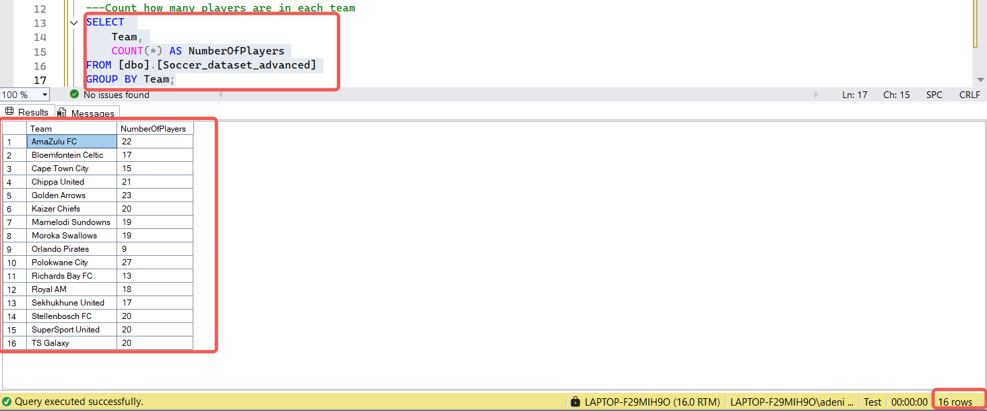

Q5. Identify the top 10 players with the most goals.

ANS:

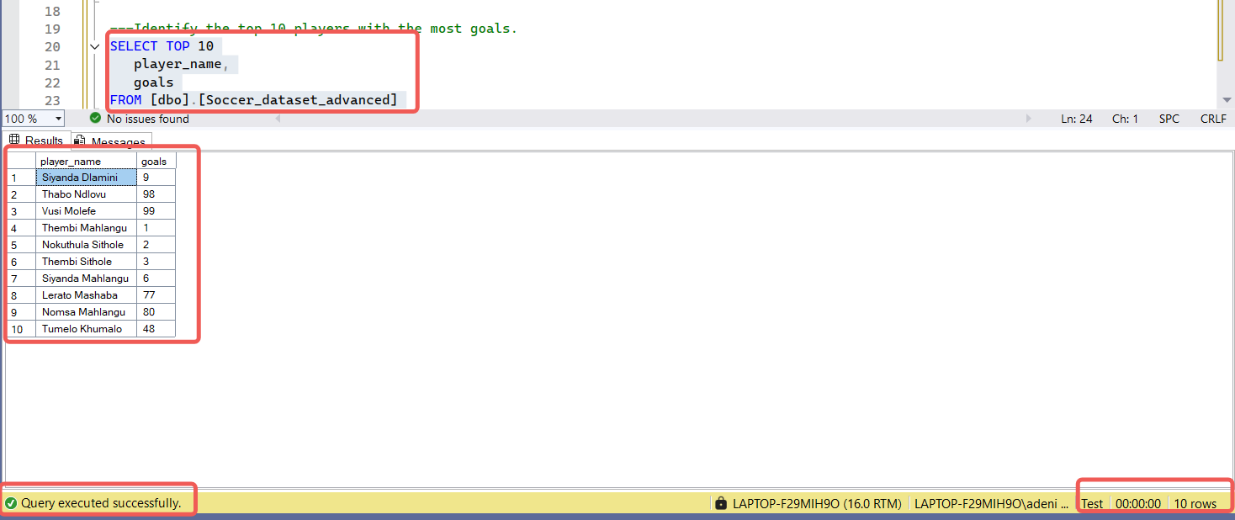

Q6. Find the average salary for players in each team.

ANS:

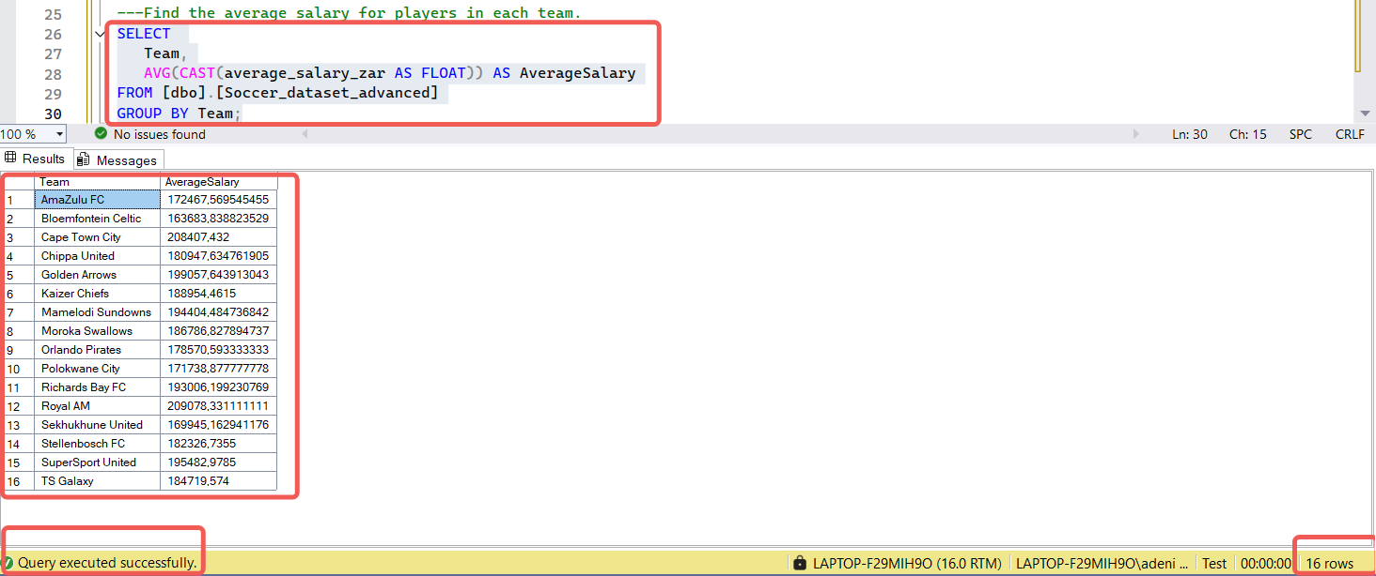

Q7. Retrieve the top 10 players with the highest market value.

ANS:

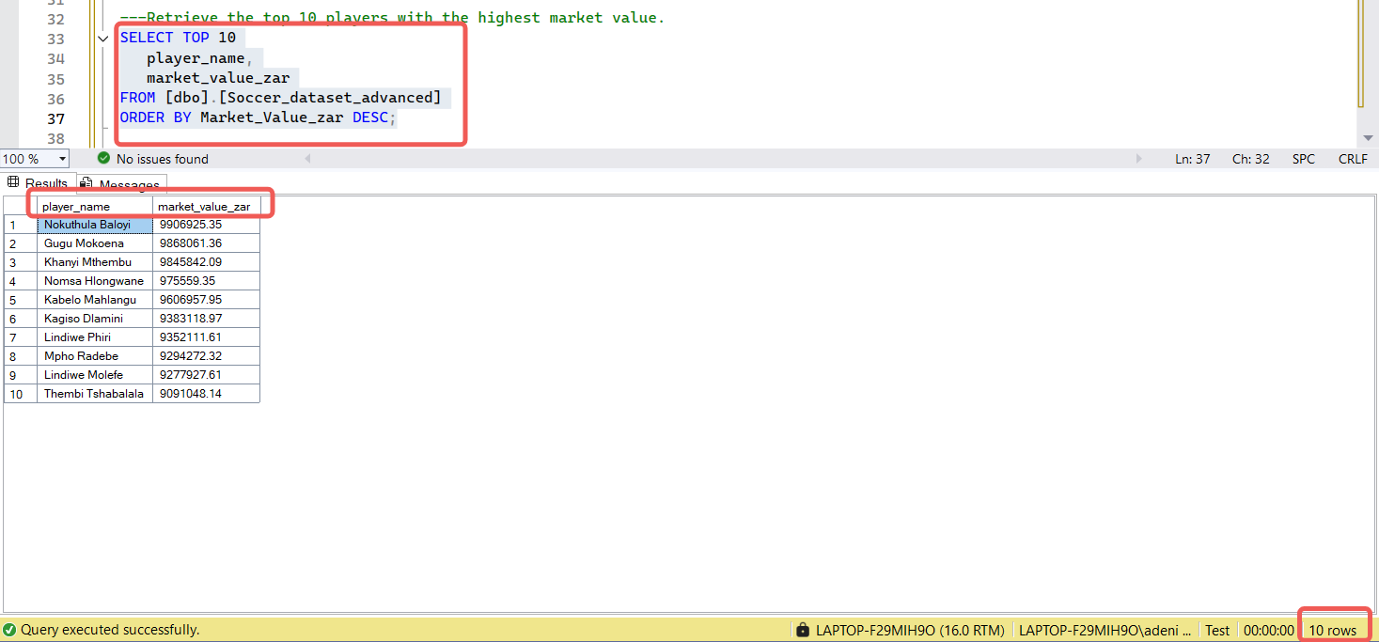

Q8. Calculate the average passing accuracy for each position.

ANS:

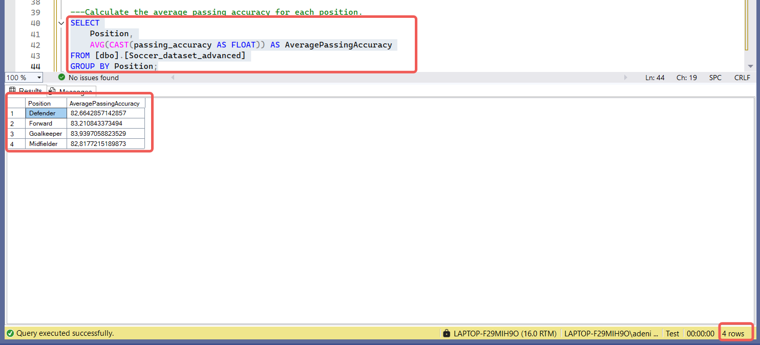

Q9. Compare shot accuracy with goals to find correlations.

ANS:

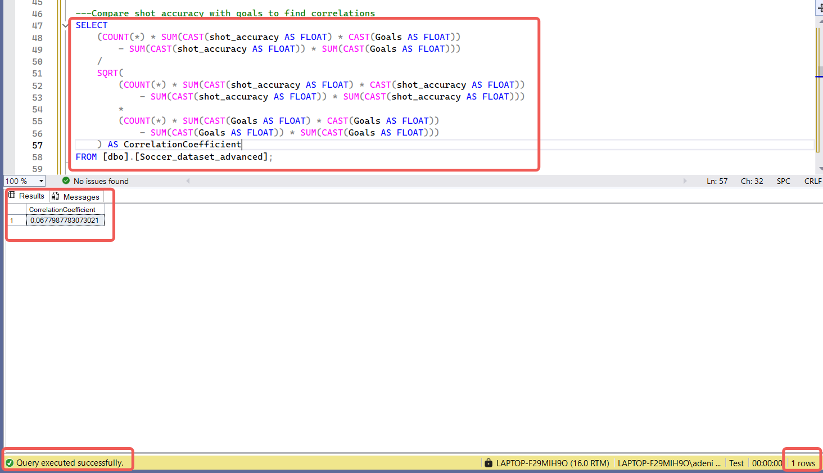

Q10. Compute total goals and assists for each team.

ANS:

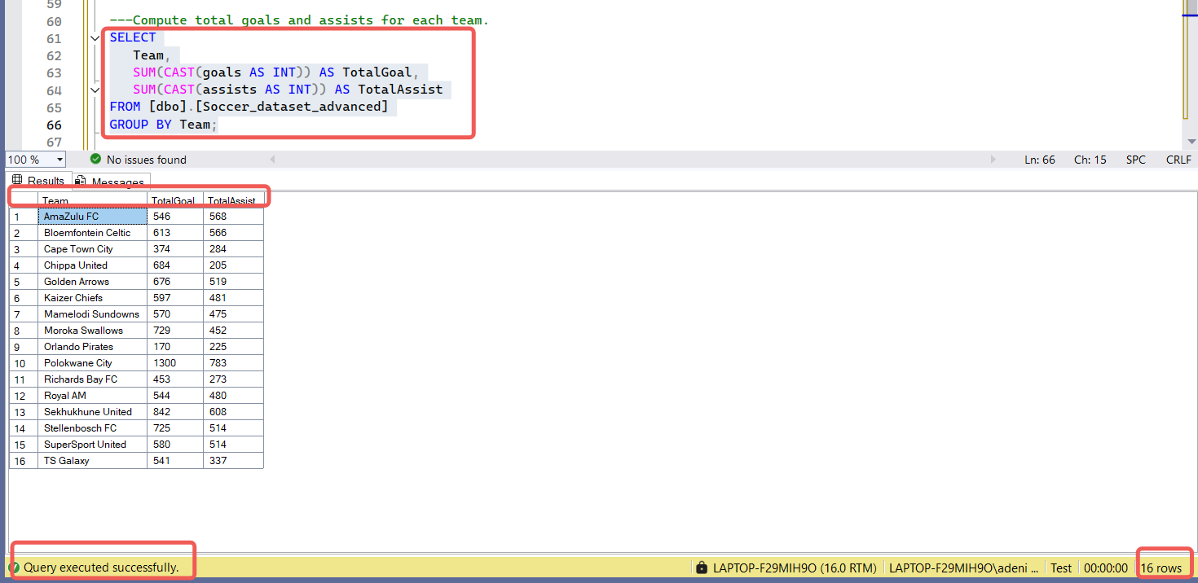

Q11. Count players by their marital status.

ANS:

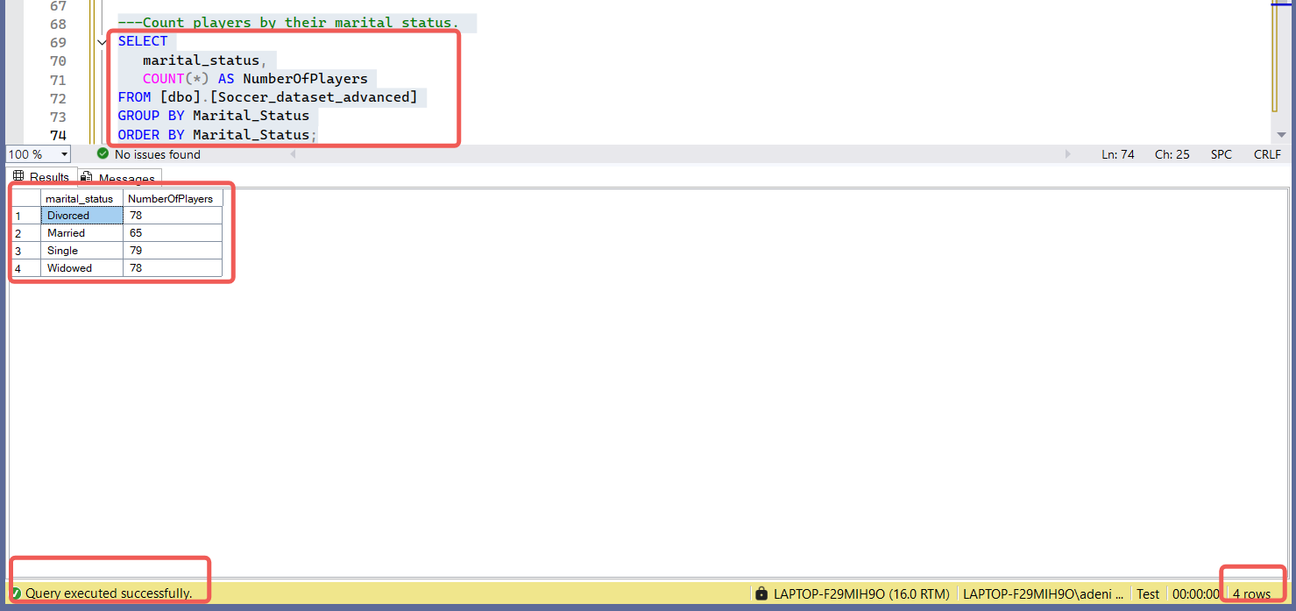

Q12. Count players by nationality.

ANS:

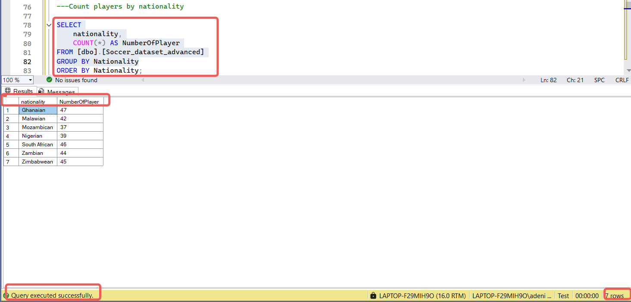

Q13. Find the average market value grouped by nationality.

ANS:

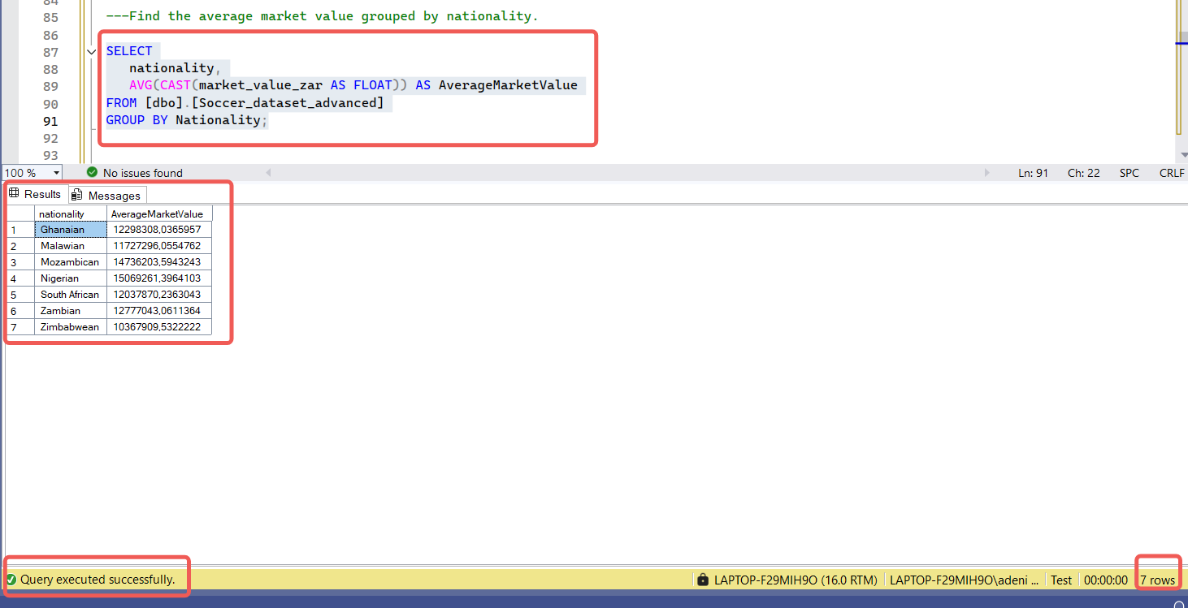

14. Determine how many player contracts end in each year.

ANS:

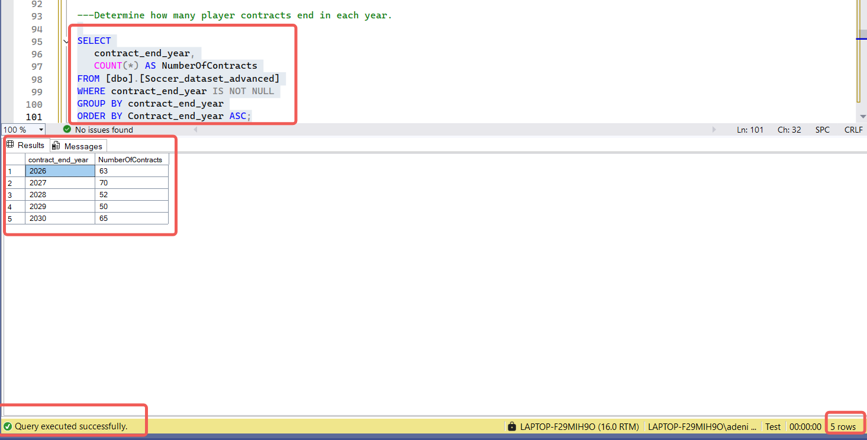

Q15. Identify players whose contracts end next year.

ANS:

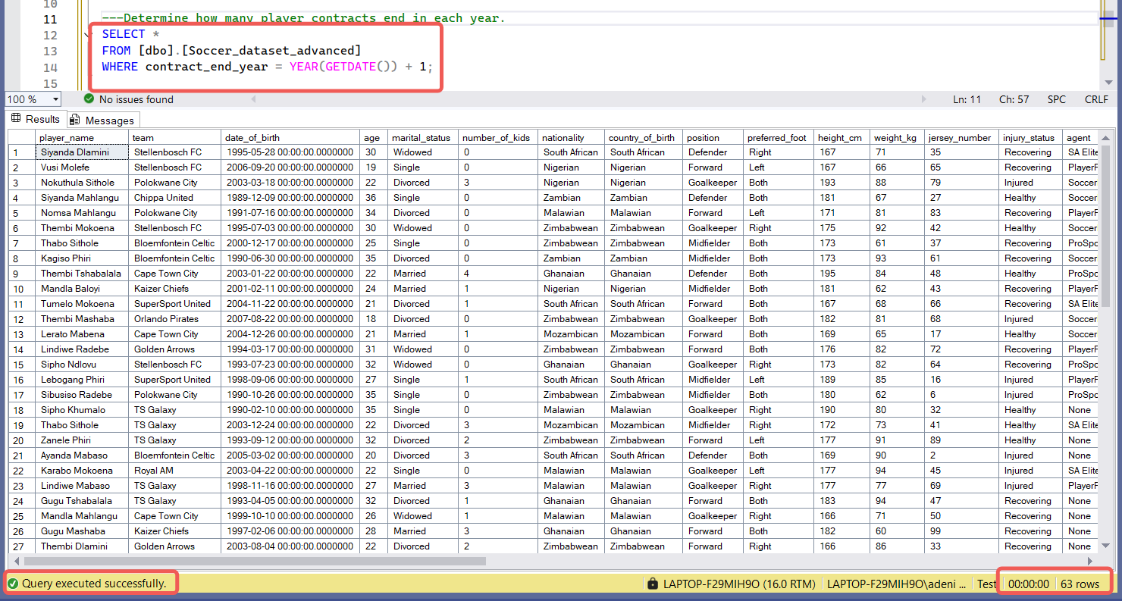

Q16. Summarize the number of players by injury status.

ANS:

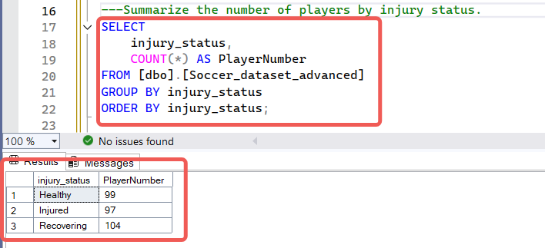

Q17. Calculate goals per match ratio for each player.

ANS:

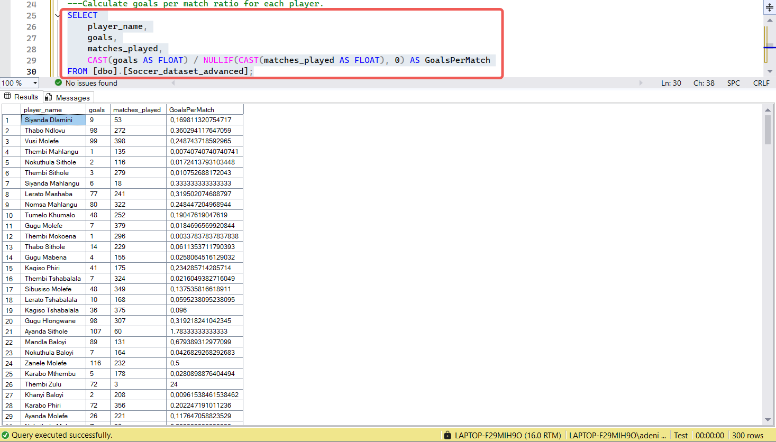

Q18. Count how many players are managed by each agent.

ANS:

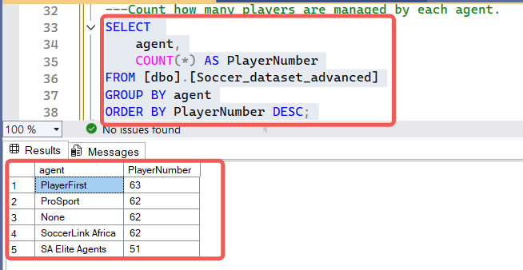

Q19. Calculate the average height and weight by player position.

ANS:

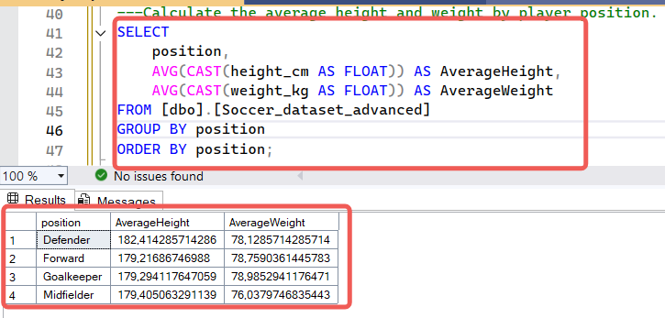

Q20. Identify players with the highest combined goals and assists.

ANS:

